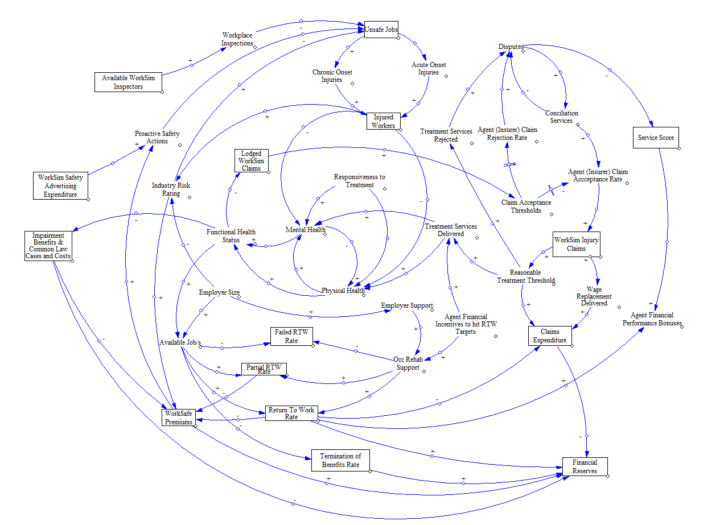

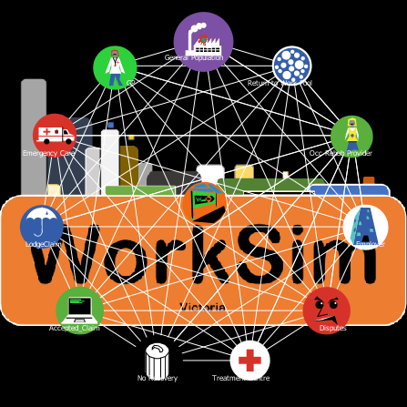

General Population

Lapsed Claims

Emergency Care

Claims Processing

Lodged Claims

RTW Pool

Occ Rehab Providers

Workplaces

Disputes

Treatment Services

General Practitioners

Advertising Spend

